
Activity 5 worksheet

Getting your robot to go in curved and straight lines

1. | 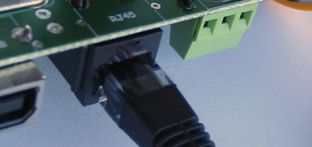  Remove switch controller from the robot.  Press HERE
2. | If you are working with the robot on a DESK  - Mark out a 60cm straight line using the black tape  - Set POT-1 and POT-3 to the following :  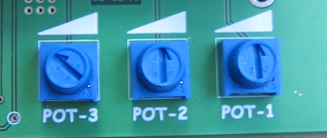 | If you are working with the robot on the FLOOR  - Mark out a 120cm straight line using the black tape  - Set POT-1 and POT-3 to the following :
3. | Power on the robot and select MODE “A0” by pressing “A_D_2A”  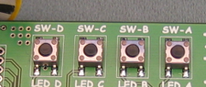  (Press SW-A, then SW-D then SW-A twice)  (shown as “A-D_2A”)
4. | When the robot display shows “A0” (no flashing) you can use any of the A, B and C switches. These switches can do the following ::  - Pressing SW-A will cause the robot to move forward.  - Pressing SW-B instructs the robot’s computer to read and remember the three POT values. (speed, differential and time)  - Pressing SW-C will exit this MODE.
5. | Place your robot at the start of your black line, set a POT-2 value, press SW-B then press SW-A to cause robot to do the move. Record your results in the table.  Repeat for the three POT-2 settings.

POT-2 setting | Setting | Observed direction
 | LOW | Table 1 POT-2 observations
 | MEDIUM
 | HIGH

6. | Using information in table 1 work out the setting for POT-2 to make your robot go as straight as possible. Record the arrow position below.  POT-2
7. | You can now experiment with the effect that the other POTs have on the way the robot behaves.  - POT-1 controls the speed of the robot  - POT-3 controls the amount of time the robot runs (from 2 to 8 seconds)
8. | Understanding what effect the three POTs have will help you in the next activity  – 10-pin bowling.

